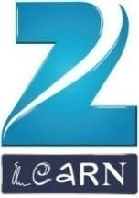
MOUNT LITERA ZEE SCHOOL
A.B. Road, Near By Pass Four Lane Circle, Gwalior

Dear Students,

The school is organizing a comprehensive Model United Nations Training session with emphasis on public speaking.

This is an exceptional opportunity for those who aspire to sharpen their interpersonal and public speaking skills along with a renewed knowledge of world affairs and diplomacy from top-notch trainer. The benefits of the training session are as follow:

i) Boosted Confidence and Morale while addressing large audiences.
ii) Enhanced knowledge of world affairs.
iii) Improved interpersonal and communication skills.
iv) Emphasis on Personality Development and Capacity Building.

Students will also be provided with Delegate Kits and Study Material for future reference.

Interested students to give their names to Ms. Deepali Alhat (Activity Coordinator - 9827353198) latest by 16 July’19.

Principal

