CLASS 3 – EXAM TIME TABLE & HALF YEARLY SYLLABUS
DATE | SUBJECT | CHAPTER NAMES
20.09.19 | EVS | - Chapter 4: Food and Balanced Diet  - Chapter 6: The World of Plants  - Chapter 7: Sound  - Chapter 8: The Rain  - Chapter 9: Importance of Water  - Chapter 12: The World of Animals
21.09.19 | ENGLISH | Literature (Vocabulary):  - Poem 3 - Little By Little  - Chapter 3 - The Enormous Turnip  - Poem 4 - Sea Song  - Chapter 4 - A Little Fish Story  - Poem 5 - The Balloon Man  - Chapter 5 - The Yellow Butterfly  Language (Grammar):  - Chapter 6 - Possessive Pronouns  - Chapter 7 - Relative Pronouns  - Chapter 8 - Interrogative Pronouns  - Chapter 9 – Articles  - Chapter 10 - Descriptive Adjectives  - Chapter 11 - Adjectives of Quantity  - Chapter 12 - Possessive Adjectives  - Chapter 13 - Adjectives of Comparison  - Chapter 14 - The Simple Present Tense  - Chapter 15 - The Present Continuous Tense  Composition:  - Extending Story Based on Hints  - Completing a Diary Entry
23.09.19 | 2ND LANGUAGE | HINDI  व्याकरणलतिका - 3 / Learning Resource  11.शब्द-भंडार  - पर्यायवाचीशब्द  10. मुहावरे  5. नामशब्द- संज्ञा  7. कैसायाकितना—विशेषण  8. करनायाहोना—क्रिया  - विरामचिह्न  रिमझिम – 3  4.मनकरताहै  5.बहादुरबित्तो  6.हमसेसबकहते  8.बंदर-बाँट  सृजनात्मकलेखन  - चित्र-वर्णन  BENGALI  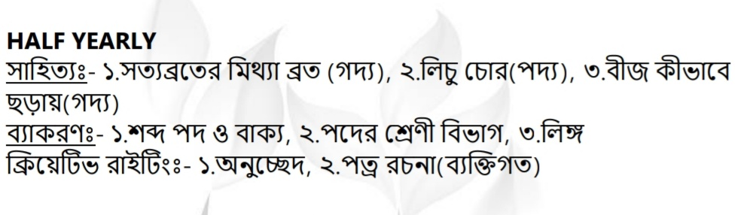
24.09.19 | COMPUTER | - STEPWISE THINKING  - INTRODUCTION TO SCRATCH  - ASANAS WHILE USING COMPUTERS
25.09.19 | MATHS | - Chapter 1: Number  - Chapter 2: Addition  - Chapter 3: Subtraction  - Chapter 4: Multiplication  - Chapter 5: Division
26.09.19 | G.K | - MY COUNTRY  - AROUND THE WORLD  - ENVIRONMENT AND THE WORLDE OF SCIENCE  - THE WORLD OF PLANTS AND ANIMALS

