Describing Picture
Fish
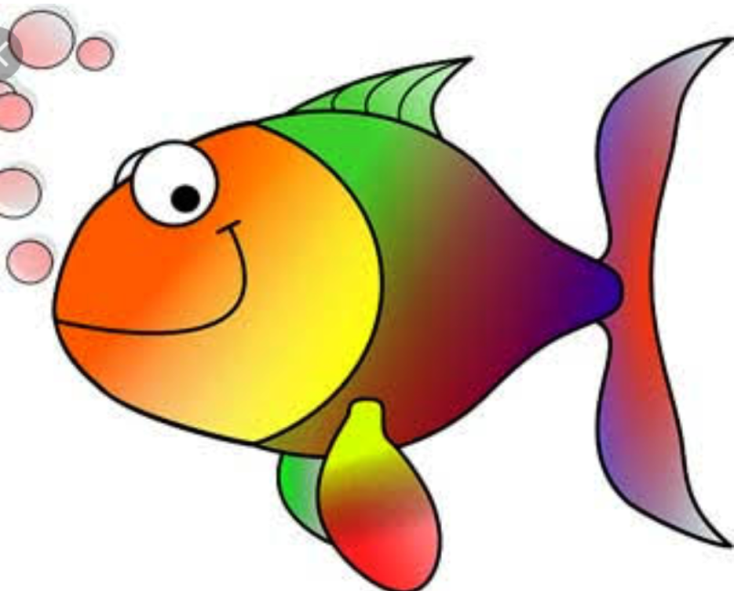
- Fish is the queen of water.
- Fish swims with the help of fins.
- Fish breathes through gills.
- Lifespan of average fish is 20 years.
- It is used for eating purpose also.
- The biggest fish is the whale fish.
- Fish is a colourful animal and they are of many kinds.

