Class 9

Chapter 2

Socialism in Europe and the Russian Revolution

Map Work

Date 26.08.2020

Major Countries of First World War
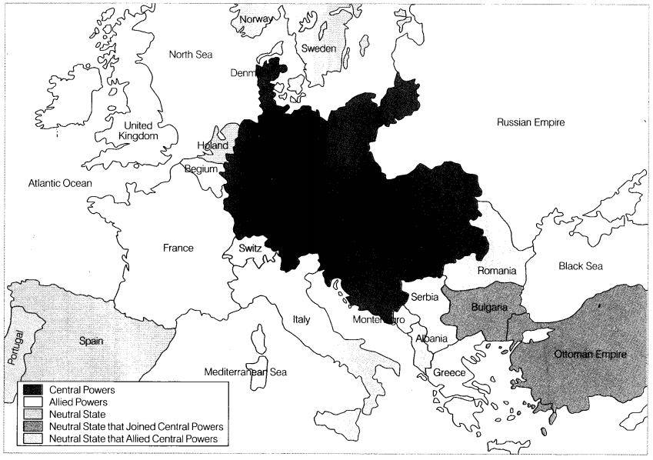
Question 1.
On the given outline map of world locate, the countries that were central powers in the First World War.
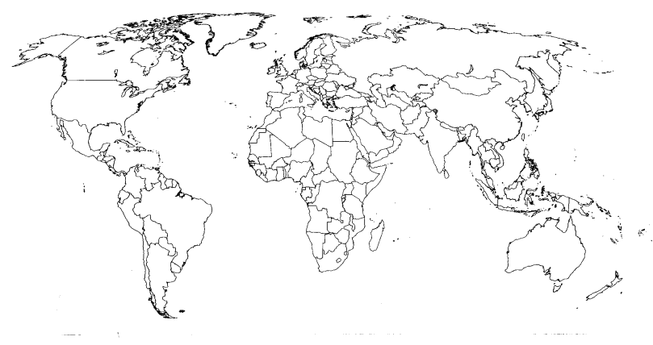
Answer:
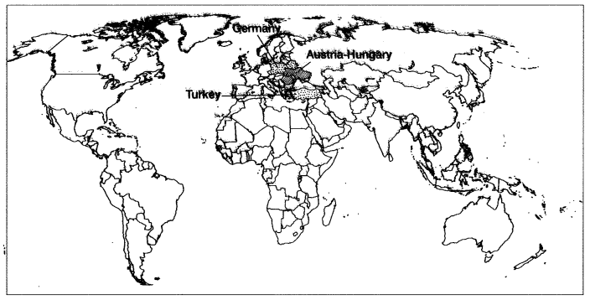
Question 2.
On the given outline map of the world, four features are marked. These are the countries that were Allied Powers in the First World War. Identify them.
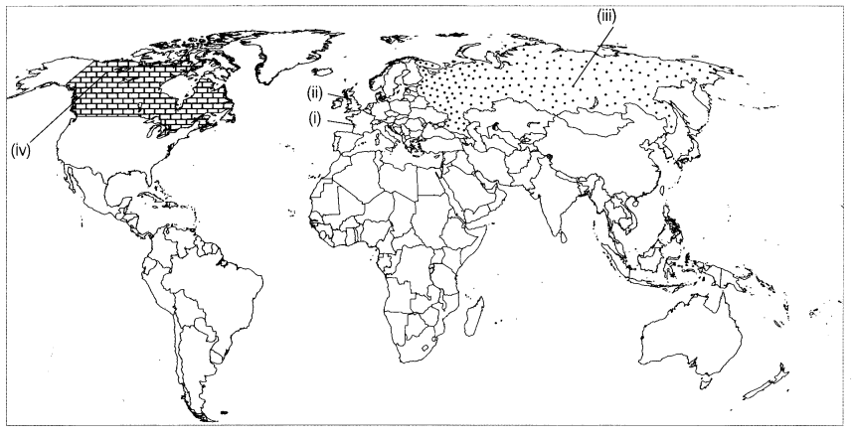
Answer:
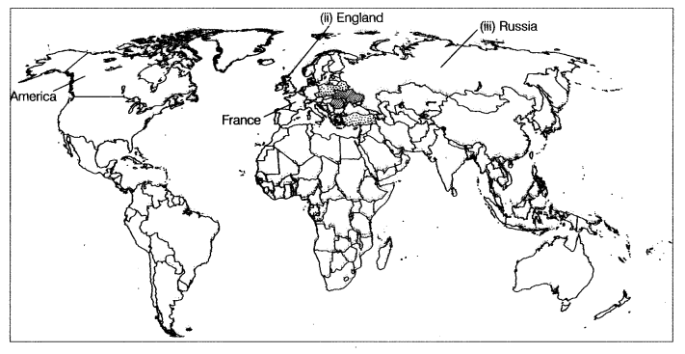
Question 3.
In the given outline map of the world, two features are marked. These are the countries that were Allied in the First World War. Identify them.
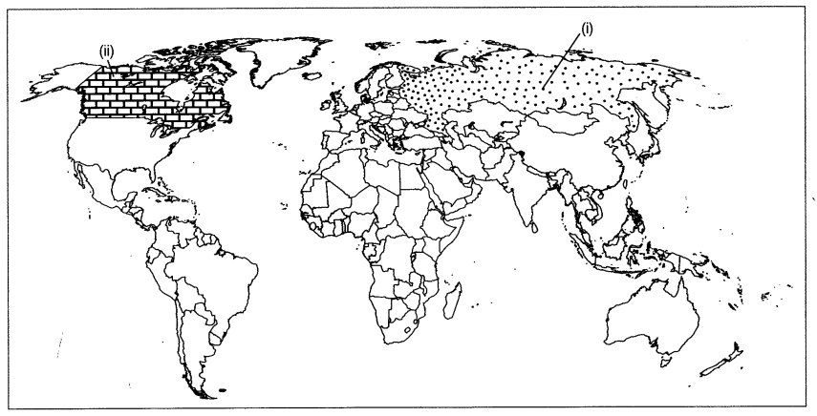
Answer:
