Chapter 2
Diversity and Discrimination
1. Match the following statements in a way that challenges stereotypes:
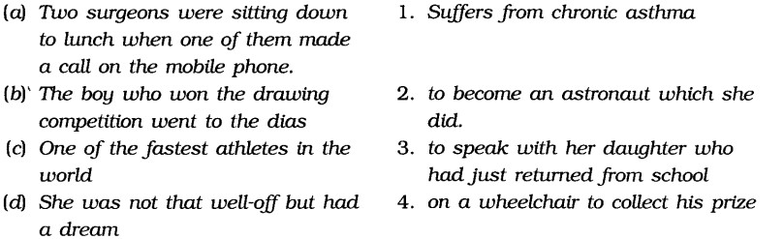
Ans: (a).3.Remark. Many people have formed a stereotype that people living in cities or having influential jobs like surgeon are busy and do not give time to their family. But this example proves that feelings for the family are universal and the surgeon wanted to talk to her daughter.
(b).4.Remark. This challenges the stereotype that crippled children are good for nothing. But the truth is that they have only one, or probably two defective organs, but they can still use their mind and talent and win prizes like this boy. .
(c).1.Remark. This challenges the stereotype that chronic asthma patients can not run fast or take part in sports.
(d).(2)Remark. This challenges the stereotype that only influential and high- class people can dream big. Even poor people can dream big and prove themselves.
2. How can the stereotype that girls are a burden on their parents affects the life of a daughter?

Ans: Girls have been treated as a burden since time immemorial. Even today their condition has not changed. Whether it is home or outside, they are not given due opportunity. The mental set-up of the parents is such that it never accepts the birth of a daughter wholeheartedly. As a result girls’ life is badly affected. Here is the list of five different effects that this stereotype can have on the way daughters get treated.
3. Imagine this situation and list at least Jive different effects that this stereotype can have on the way daughters get treated in the house.
Girls would feel discouraged and they would not concentrate to their studies.
All their dreams to achieve separate identity in the society would be shattered. Sometimes girls are not allowed to join any school or college.
- This ruthless altitude of the parents towards their daughters ruin their career. They feel helpless even in their parents’ house.
Even marriage does not bring fortune to the girls all the time. Some in-laws prove themselves good by giving proper treatment to the newly married girls. But most of the time we find that they are ill-treated in their in-laws’ house. They are subject to exploitation.

